With Revel's Como Loyalty Integration, your customers can sign up for Como Loyalty while using the CDS XT directly in store. This allows for more functionality and flexibility in integrations and for more ease-of-use while signing up customers. This walkthrough demonstrates the screens the customer will experience in this process.

### **Contents**

* Create New Como Loyalty Account
* Log In to Existing Como Loyalty Account (Before the Order Is Finalized)
* Finalize Como Loyalty Account
* Attempted Login with No Loyalty Account
* No Rewards Available

### **Create New Como Loyalty Account**

1. At the **Your Order** screen on the CDS, tap **Earn Rewards**: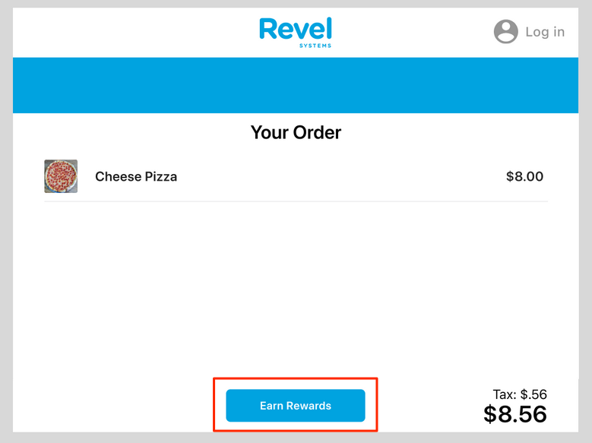
2. Tap **Create Account**: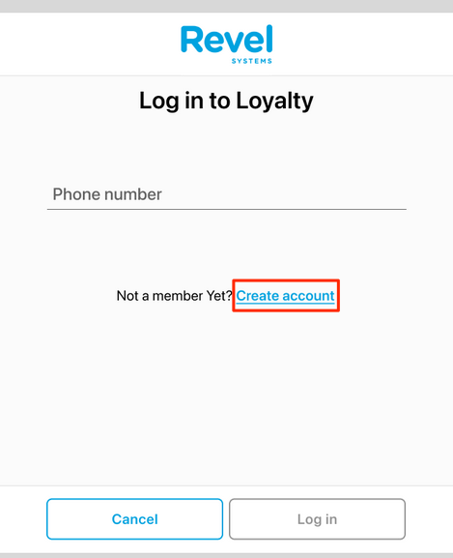
3. Fill out the form fields and tap **Submit**: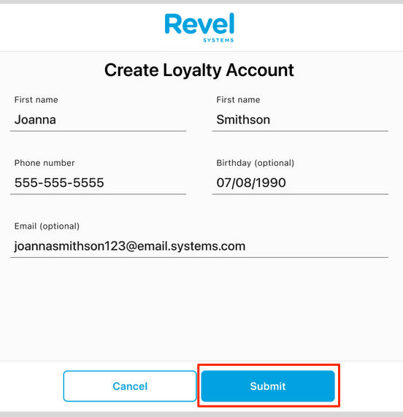
4. The customer should then verify the information and agree to or skip these checkboxes. Although none of the items are required to complete the purchase, the top checkbox is necessary to agree to the terms and conditions, the privacy policy, and the loyalty terms in order to participate in the rewards program. Then, tap **Create Account**: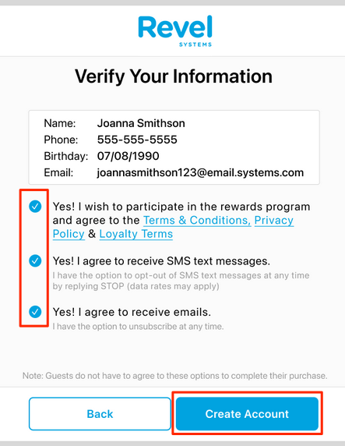
5. The screen will show that the setup is complete: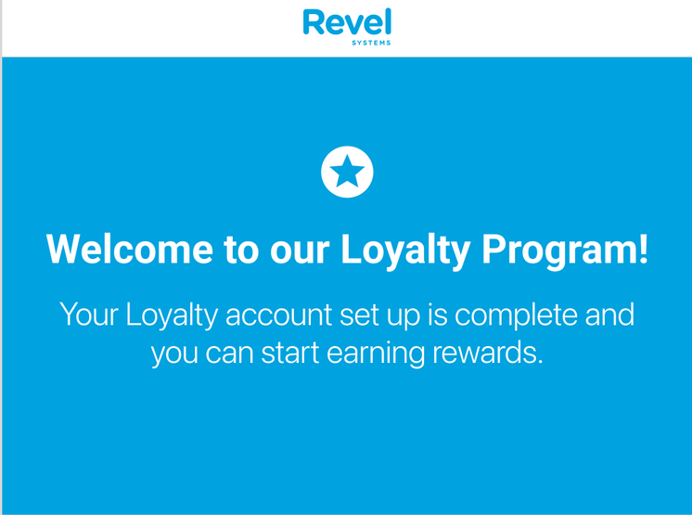
6. The screen will also show the customer's current total reward points: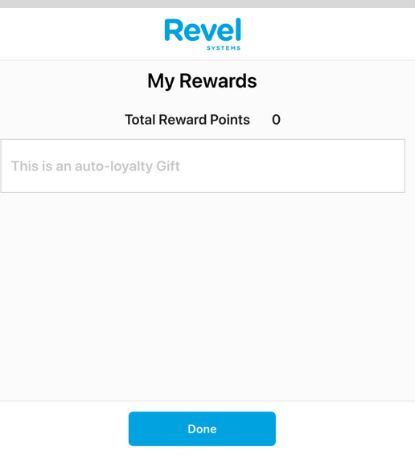
7. Finally, the screen will return to the **Your Order** screen, applying any automatic discount rewards: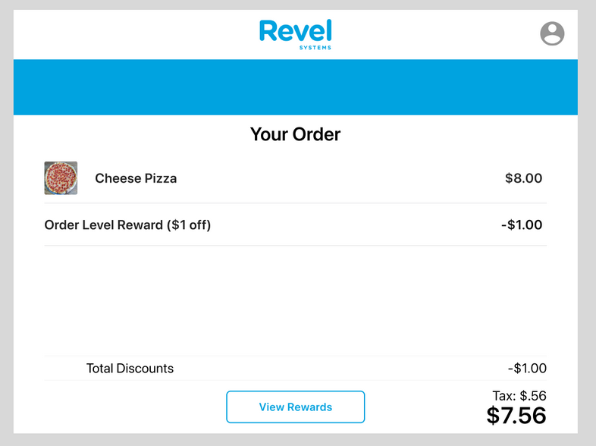

### **Log In to Existing Como Loyalty Account (Before the Order Is Finalized)**

If a customer wants to log in to their loyalty account on the CDS to see available rewards before they start their order, they can now see all rewards that are available. Then, the customer can tell the cashier what they would like to add to their order. Once the cashier adds items to the order and taps the **Pay** button on the POS, the customer will be able to apply rewards based on what is applicable to the order.

1. At the **Your Order** screen, tap **Earn Rewards**: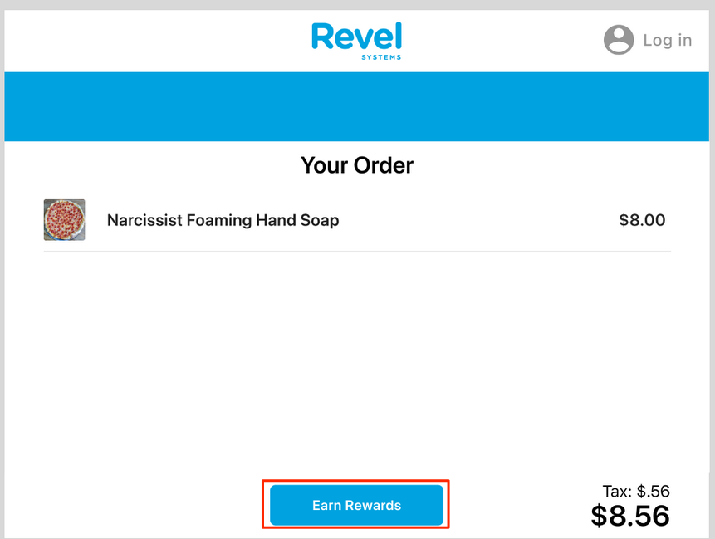
2. Input the account phone number and tap **Log In**: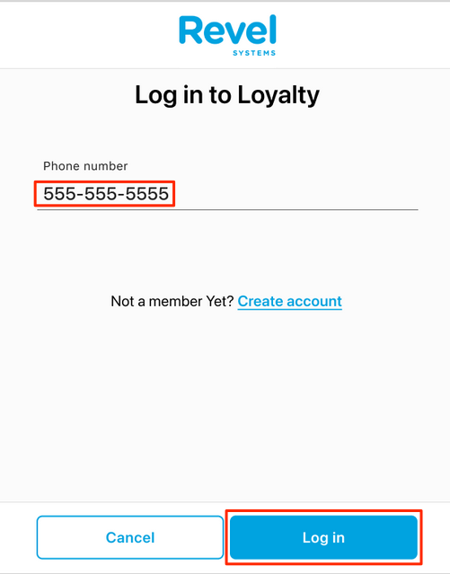
3. The screen will welcome the customer and state if there are rewards available: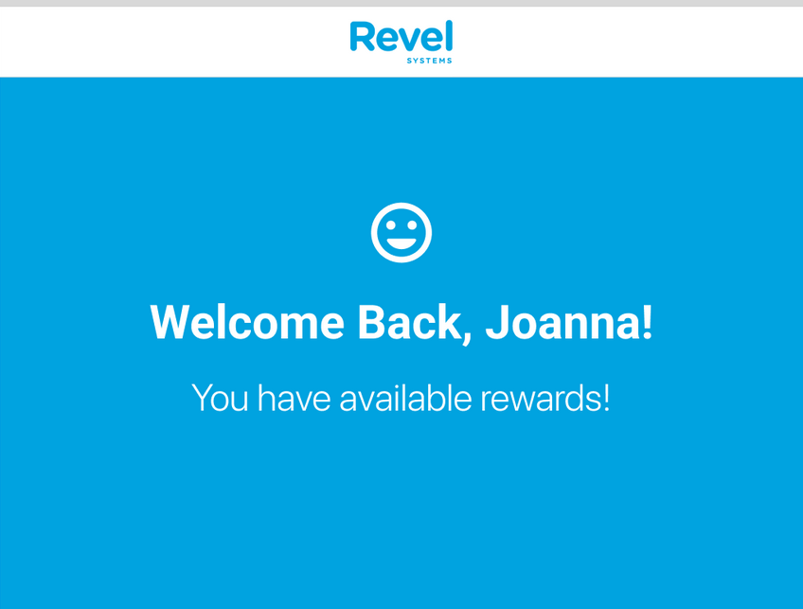
4. While waiting for the cashier to finalize the order, the customer can move between these two screens by selecting **Done** or **View Rewards**: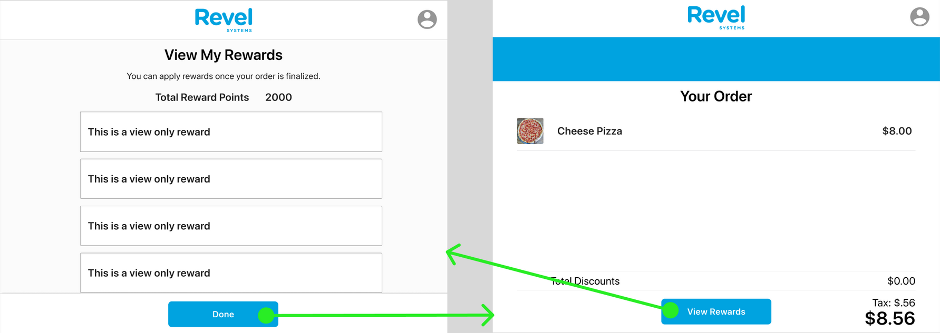
5. Once the cashier has finalized the order, the customer can choose an applicable reward and can apply the selected reward by tapping **Apply Rewards**. The **Your Order** screen will appear, showing any applied rewards: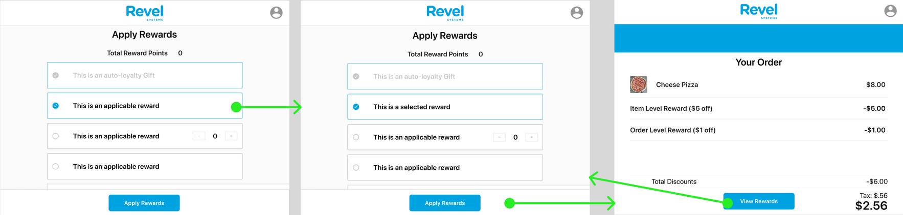

### **Finalize Como Loyalty Account**

If a customer has already created a loyalty account but never agreed to the terms & conditions or privacy policy, then the customer will be unable to apply rewards or earn points until they do so and finalize the account.

1. At the **Your Order** screen, tap **Earn Rewards**: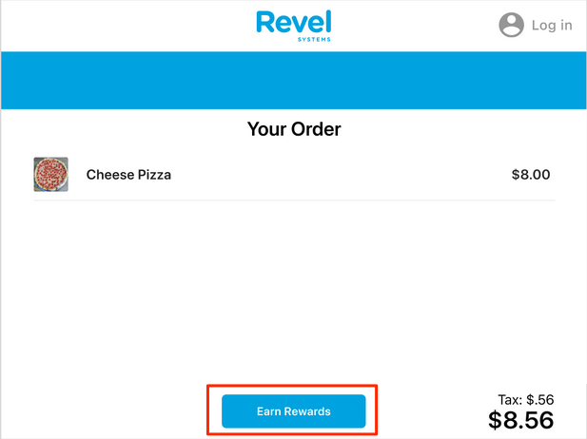
2. Input the account phone number and tap **Log In**: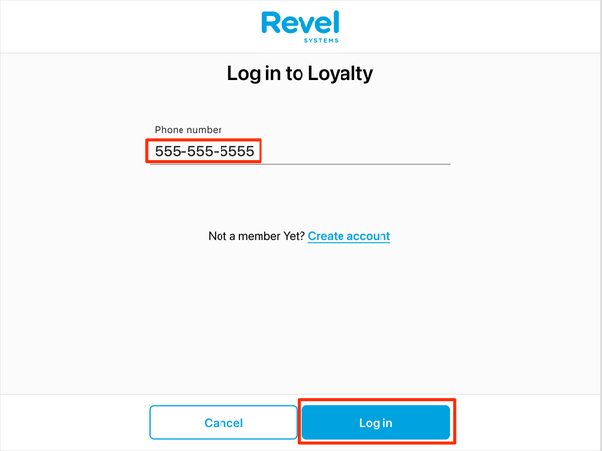
3. Fill out the form fields and tap **Submit**: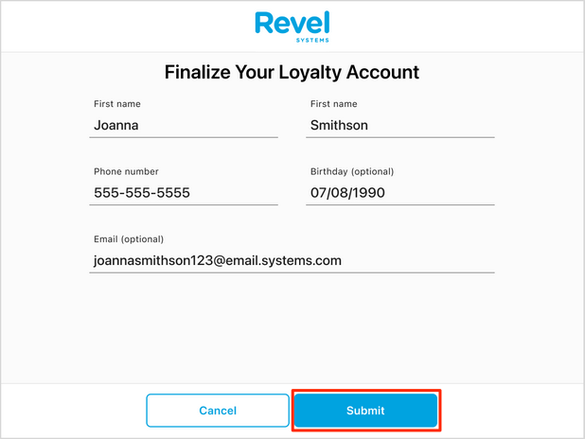
4. The customer should verify the information. If the customer wants to finalize their Como Loyalty Account, they must check the top box, which agrees to the terms and conditions, privacy policy, and loyalty terms. Then, tap **Verify Account**: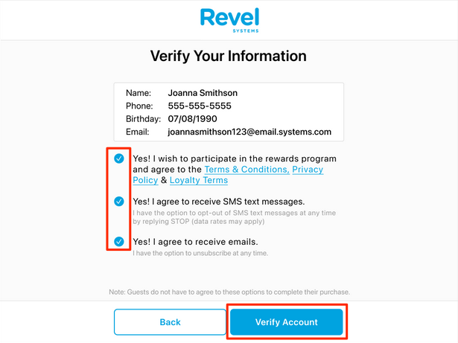
5. The screen will show that the account has been finalized and rewards can be redeemed: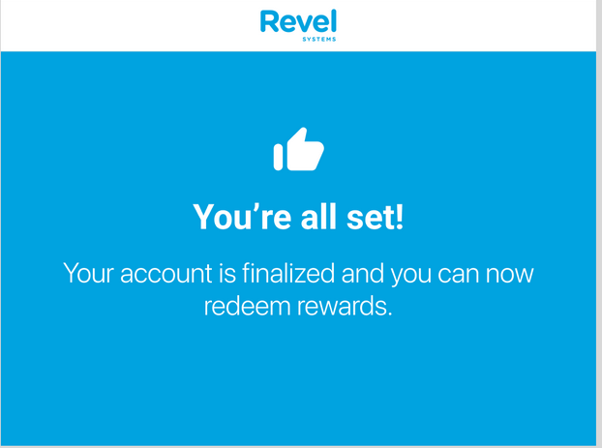
6. Select a reward and tap **Apply Rewards**: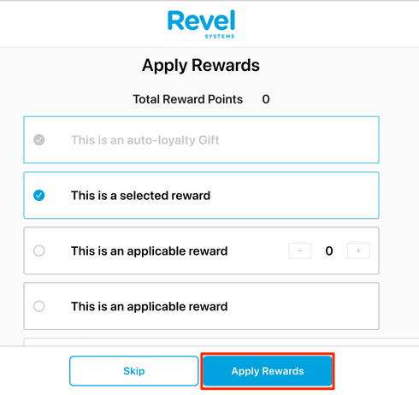
7. The screen will return to the **Your Order** screen, applying any discount rewards: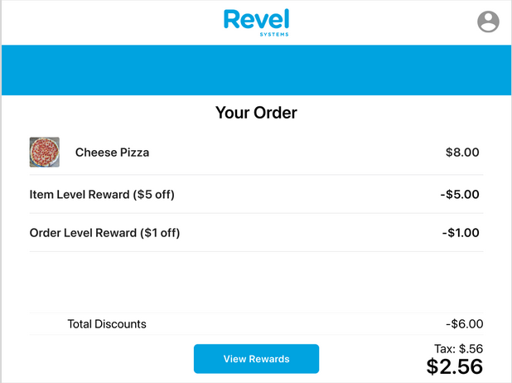

### **Attempted Login with No Loyalty Account**

1. If the customer attempts to log in with a phone number not linked to an existing account, the screen will display an error message. The customer can then select **Create Account** to begin the account creation process: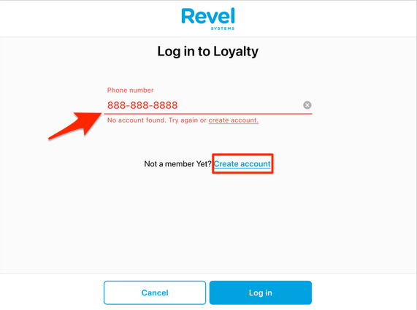
2. The most recently attempted phone number will autofill in the **Phone number** field. The customer will then fill out the remaining fields and will follow the same process described in the **Create New Como Loyalty Account** section above: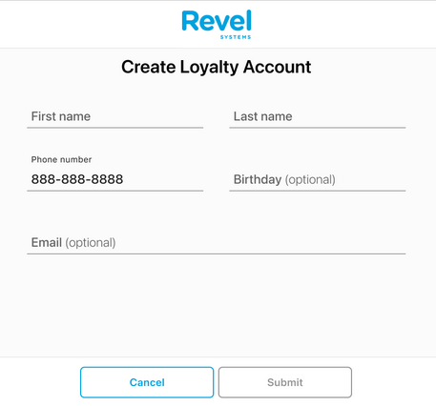

### **No Rewards Available**

If the customer logs in to their rewards account but does not have any available rewards, the **View Rewards** screen will be skipped.

1. At the **Your Order** screen, tap **Earn Rewards**: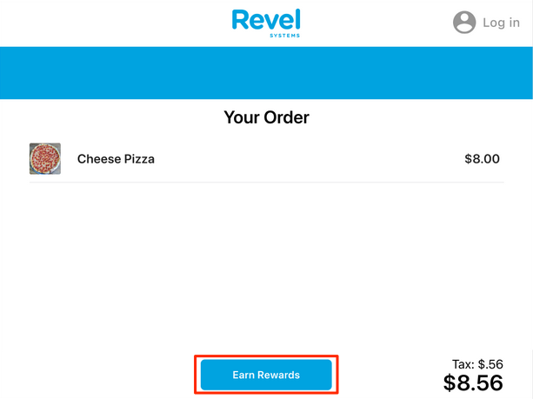
2. Input the account phone number and tap **Log In**: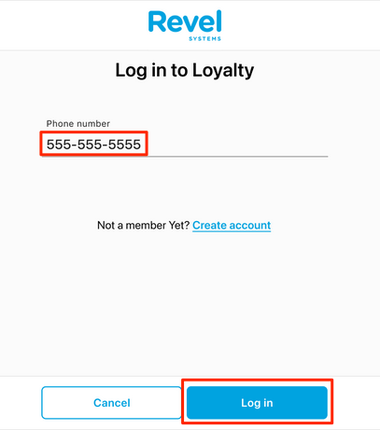
3. The screen will welcome the customer: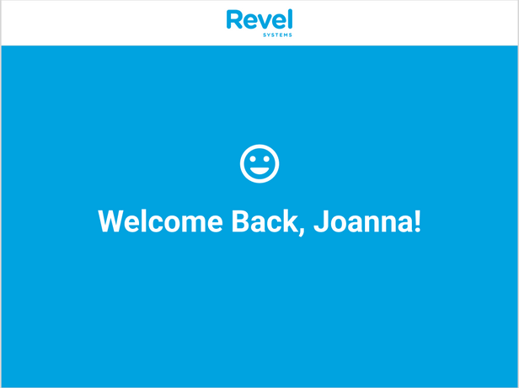
4. If the customer does not have any rewards, the **View Rewards** screen will be skipped entirely, and the **Your Order** screen will be displayed: